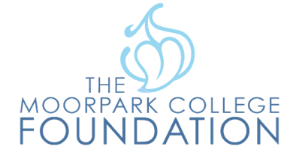

FOR IMMEDIATE RELEASE

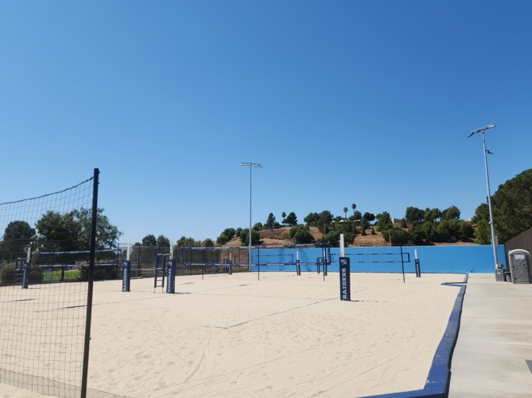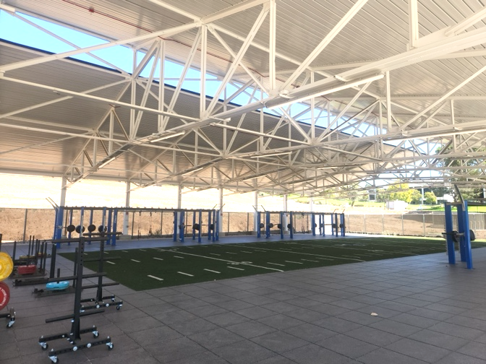

**Moorpark College Hosts Grand Opening Ceremony for New Athletics Facilities***Beach Volleyball Stadium and Outdoor Training Center Expand Opportunities for Student-Athletes and Community*

**Moorpark, Calif.** (Oct. 23, 2024) — Moorpark College will celebrate the grand opening of its Beach Volleyball Stadium and Outdoor Training Facility on Thursday, October 31, 2024, at 1 p.m. The ceremony will feature live demonstrations by student-athletes and distinguished speeches by Julius Sokenu, president of Moorpark College; Adam Black, women’s volleyball coach; and Jeff Kreil, Kinesiology faculty.

The first of its kind in Ventura County, the Beach Volleyball Stadium has eight NCAA-regulation courts complete with officiating stands, stadium lighting, and an outdoor shower.

“These state-of-the-art facilities demonstrate the college’s commitment to providing our scholar athletes and the general student population the best learning environments to pursue excellence in their sport,” said Sokenu. “These additions further the campus’ reputation as a preferred destination for academic, cultural and athletic programming.”

Located adjacent to the campus parking structure and next to an open field for visiting teams to set up, the courts are easily accessible for athletic competitions and community events.

“The beach volleyball stadium will serve as the home courts for the Raiders beach volleyball team and 3C2A Beach Volleyball contest during the spring season as well as Kinesiology courses,” said Black. “Additionally, the courts may be used to host CIF competition, NCAA competition, and youth beach volleyball organizations. During the summer youth clinics will be conducted.”

The Outdoor Training Facility is Moorpark College’s new open-space fitness instruction and training classroom, exclusively catering to enrolled students. This one-of-a-kind space is large enough to host up to 100 students using a variety of equipment, such as kettlebells, medicine balls, barbells, battle ropes, sandbags and tires, to name a few. Leveraging a state-of-the-art roof structure, users are unrestricted by the elements and can enjoy this classroom all year round.

“Students enrolled in the Exercise Science program use this facility to refine their skills with training individual and small-group clients, using innovative modalities for a variety of health and fitness goals, while the Moorpark College athletics programs utilize the massive space to conduct corrective and sports performance conditioning with their student-athletes,” said Kreil.

For information regarding the outdoor volleyball stadium, contact Adam Black at [ablack@vcccd.edu](mailto:ablack@vcccd.edu) or 805-553-4623.  If members of the public are interested in attending the grand opening, contact the Moorpark College Foundation at mcfoundation@vccd.edu or 805-553-4760.

**About Moorpark College**

*Moorpark College’s student-first philosophy embraces equity, social justice, anti-racism, and intersectionality. We empower learners from local, national, and global backgrounds to achieve their certificate, associate and baccalaureate degree, and transfer and career education goals. Through the integration of innovative instruction and holistic student support, our programs are designed to foster equitable student outcomes. To learn more, visit*[*MoorparkCollege.edu*](http://MoorparkCollege.edu)*or follow @MoorparkCollege on social media.*

**About Moorpark College Foundation**

*We serve Moorpark College and all its students by securing resources to empower our students to achieve academic, economic, and personal goals. We change lives for the better. Learn more about*[*Moorpark College Foundation*](https://www.moorparkcollege.edu/community/foundation)*.*

**Media Contact**

Deborah Klein  
Chief Development Officer  
Moorpark College Foundation  
dklein@vcccd.edu  
805-553-4760