|  |
| --- |
| Picture 1 |

**FOR IMMEDIATE RELEASE**

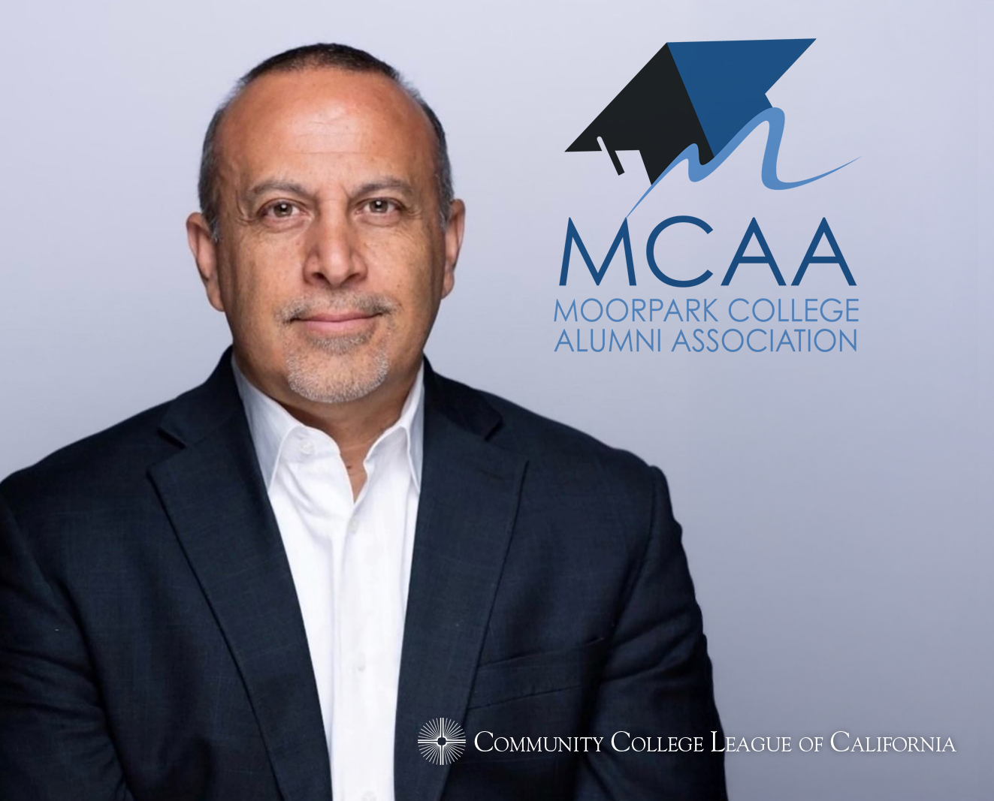

**Moorpark College Alumnus Recognized as a 2024 Distinguished Alumni Honoree** *Community College League of California to Celebrate Honorees at Annual Convention*

**Moorpark, Calif.** (Nov. 18, 2024) — Moorpark College alumnus Mike Madrid will be honored with the 2024 Distinguished Alumni Award by the Community College League of California (CCLC) at its Annual Convention on November 22 in Burlingame, California.

Madrid and fellow honorees Marlin “Skip” Davies (Yuba College) and Mike McGuire (Santa Rosa Junior College) were nominated by their peers and colleges to receive this honor.

"On behalf of the Community College League of California, I am immensely proud to celebrate the 2024 Distinguished Alumni Award honorees,” said Larry Galizio, CCLC president and CEO.  “Their achievements exemplify the transformative power of California's community colleges and reflect the profound impact our community colleges have on individual lives and our society as a whole."

Madrid, Davies and McGuire join a class of more than 200 California community colleges alumni who have received this honor.

“Community colleges are the foundation where dreams take root, and future leaders begin to flourish,” said Roger Schultz, president of the Chief Executive Officers of the California Community Colleges (CEOCCC) board and League board chair. “The 2024 Distinguished Alumni Award recipients remind us how these institutions cultivate academic skills, resilience, adaptability, and a profound commitment to the community. The journeys of our distinguished alumni prove that the values and lessons nurtured by our community colleges extend far beyond the classroom, empowering them for life-long success and leadership."

The honorees were selected by League Board of Directors members Schultz, California Community College Trustee (CCCT) board president Nan Gomez-Heitzeberg and California Community Colleges Classified Senate president Deborah Knowles.

“Mike Madrid’s recognition as a Distinguished Alumni Award honoree is a testament to the power of education and the incredible impact Moorpark College alumni have on their communities and beyond,” said Julius Sokenu, president of Moorpark College. “We are proud to see his success reflect the values and opportunities that Moorpark College strives to provide for all its students.”

During his time at Moorpark College, Madrid served as Associated Student Body president–an experience that became the foundation for his professional career. He was appointed by California Gov. Pete Wilson as a student representative on the California Community College Board of Governors. Madrid later transferred to and graduated from Georgetown University, where his senior thesis centered on Latino voters and Latino politics became the foundation for his career.

Today, Madrid is a nationally recognized expert on Latino voting trends, with more than two decades of work impacting elections and political campaigns across the U.S. As a pioneer in Latino communications and outreach strategies in state, local and national political campaigns, Madrid has worked for major campaigns on both sides of the aisle with organizations such as the California Republican Party and the League of California Cities. Madrid co-founded the Lincoln Project in 2020 and recently published his book, “The Latino Century,” in June 2024.

To learn about how Moorpark College supports student success and explore ways to contribute to the journeys of future distinguished alumni, visit [MoorparkCollege.edu/Foundation](https://www.moorparkcollege.edu/foundation).

**About Moorpark College**

*Moorpark College is one of three colleges in the Ventura County Community College District and annually serves more than 14,000 students. Founded in 1967, Moorpark College is fully accredited and has the highest six-year completion rate within the California Community College System. An Aspen Institute Top 10 Finalist for 2023, Moorpark College has also been named a 2020 Champion of Higher Education by The Campaign for College Opportunity for the Associate Degree for Transfer Pathway. It is also a designated Hispanic-Serving Institution. The college’s signature career/technical programs include nursing, radiologic technology, biotechnology and journalism. The college’s America’s Teaching Zoo is the only associate degree exotic animal training program in the country. To learn more, visit* [MoorparkCollege.edu](http://MoorparkCollege.edu) *or follow @MoorparkCollege on social media.*

**Media Contact:**

[communications@vcccd.edu](mailto:communications@vcccd.edu)  
805-652-5502