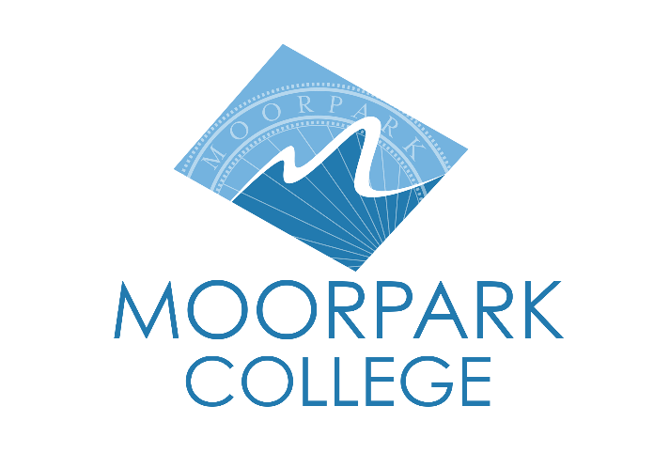

FOR IMMEDIATE RELEASE

Come Together Concert Brings Musical Magic to Moorpark College
Student-Driven Concert Returns for Another Unforgettable Showcase

Moorpark, Calif. (March 18, 2025) — Moorpark College’s music students are bringing their talents to the stage with Come Together, a two-night concert event featuring an eclectic mix of classic hits, modern favorites, and original student compositions. Performances will take place at the Moorpark College Performing Arts Center on April 4–5, including a free matinee for local students and seniors.
With 40 songs across two unique concert lineups, this production highlights the creativity and dedication of the college’s up-and-coming musicians. Come Together is produced and performed by Moorpark College Music Technology students as part of their academic exploration of music, performance, and production.
“This production is not just a concert; it’s a celebration of our students’ dedication and passion for the arts,” said Nathan Bowen, Performing and Media Arts department chair at Moorpark College. “We are so proud of the talent and hard work our students have poured into this performance, and we’re excited to share it with the community. We sold out shows the past two semesters, and momentum has been growing for this to be a true showcase of a legitimate local music scene of up-and-coming talent.”
A two-day concert event, Come Together kicks off with a free matinee on Friday, April 4, from 11 a.m. to 1 p.m., open to local high school students, Moorpark College students, and seniors (65+) by reservation. Additional performances will be held Friday, April 4, at 7:30 p.m., and Saturday, April 5, at 2 p.m. and 7:30 p.m. Tickets are available for purchase at MoorparkCollege.edu/PAC, with proceeds directly supporting the Moorpark College Music program and future productions.
For more information or to reserve tickets, visit MoorparkCollege.edu/PAC. To RSVP for the free matinee performance, contact Krista Lederer at klederer@vcccd.edu. Don’t miss the chance to experience the energy, talent, and creativity of Moorpark College’s music students live on stage!
About Moorpark College
Moorpark College is one of three colleges in the Ventura County Community College District and annually serves more than 14,000 students. Founded in 1967, Moorpark College is fully accredited and has the highest six-year completion rate within the California Community College System. An Aspen Institute Top 10 Finalist for 2023, Moorpark College has also been named a 2020 Champion of Higher Education by The Campaign for College Opportunity for the Associate Degree for Transfer Pathway. It is also a designated Hispanic-Serving Institution. The college’s signature career/technical programs include nursing, radiologic technology, biotechnology and journalism. The college’s America’s Teaching Zoo is the only associate degree exotic animal training program in the country. To learn more, visit MoorparkCollege.edu or follow @MoorparkCollege on social media.

Media Contact:
Nathan Bowen
Department Chair
Performing & Media Arts
805.377.0588
nbowen@vcccd.edu

