|  |
| --- |
|  |

**FOR IMMEDIATE RELEASE** 

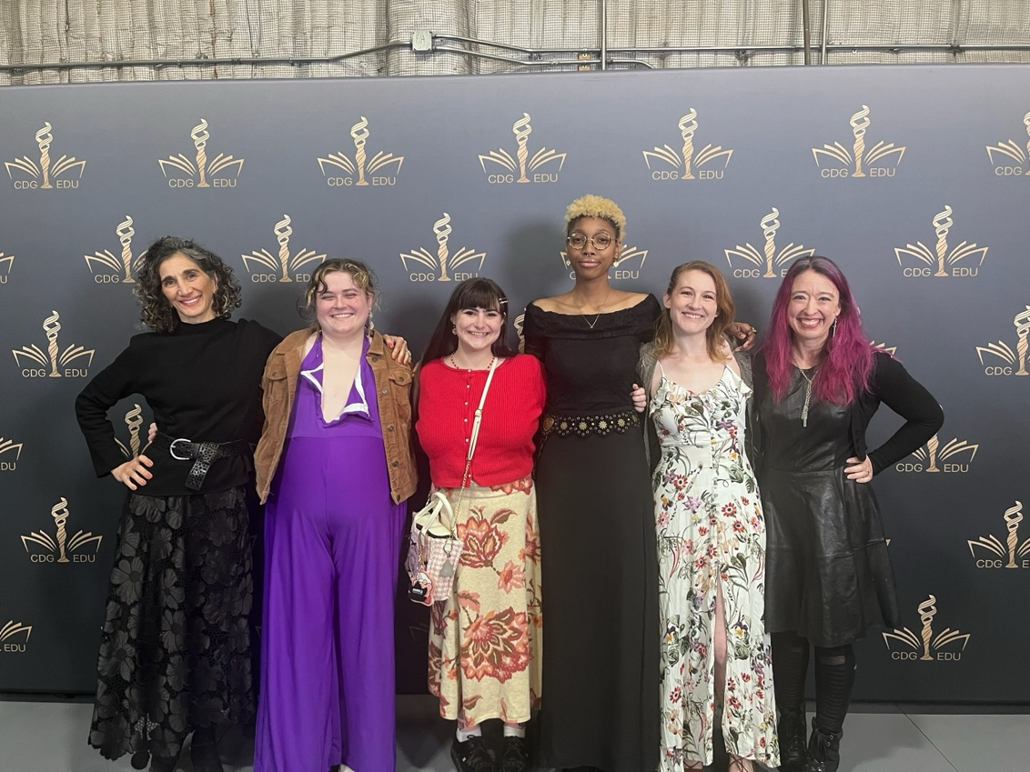 

**Costuming Students from Moorpark Theatre Arts Program Stitch Together Employment and Industry Accolades**

*Student achievements highlight the program’s reputation for excellence in costuming and technical theatre*

**Moorpark, Calif.** (Feb. 28, 2025) — The Moorpark College Theatre Arts and Film, Television, and Media Arts programs recently hosted their annual advisory board meeting, where industry professionals and college faculty collaborate to ensure programs align with industry and workforce needs. During the meeting, faculty member and professional costumer Haleh Risdana proudly highlighted the industry successes and recognitions of several outstanding students: Marina Wagner, Evelyn Rogers, Rhiann Olshane, Kristen Fernandez, and Noa Walker.

These students have earned several notable achievements:

* **Recognition by Costumer’s Guild West:** Moorpark College costume students have been invited to attend the prestigious Costume College event, *The Costumer’s Journey*, in July 2025. Notably, Rhiann Olshane has received the Costume College scholarship three years in a row and has showcased costumes from Moorpark College productions in the Costumer’s World West exhibition. Noa Walker has also attended Costume College. This year marks the first time that a college has been invited as an official group at this event and Moorpark College is proud to carry that distinction.
* **Engagement with the Costume Designers Guild IATSE 705:** Costumers Evelyn Rogers (*Our Lady of the Tortilla*), Kristen Fernandez (*The Tempest*), Noa Walker (*Sweeney Todd, Twelfth Night*), and Marina Wagner (*Sweeney Todd, Jesus Christ Superstar*), along with Moorpark instructor, Haleh Risdana and Costumer’s Guild West President Samantha Barry, attended the Costume Designers Guild IATSE 705 event honoring renowned costume designer Jenny Beavan (*Cruella, The King’s Speech, Furiosa*).
* **Recognition by the Motion Picture Costumers IATSE 705:** Moorpark College is now listed on the Motion Picture Costumers IATSE 705 website as a recommended institution for costuming education. This recognition has already brought new students to the program, including second-semester student Ren Friedman, who enrolled after discovering Moorpark College on the organization’s education and training page.
* **Professional Employment Opportunities:** Most recently, Marina Wagner was hired by Valley Opera and Performing Arts (VOPA) to design and oversee the costumes for their production of *Oklahoma!* at the El Portal Theatre in North Hollywood (NOHO).

“All of these successes could not have happened without the full support of the Administration at Moorpark College and the funding provided by the Perkins and Strong Workforce grants through our Career Education Workgroup,” said Risdana. “Students come to our costuming program from varied backgrounds and experiences. Some want to learn to sew, some are already professional customers who want to learn how to do things by the book, others are students who have had positive Theatre Arts experiences in high school. What they all have in common is that they are having a great experience while working towards doing what they love and turning it into a career.”

These achievements underscore the growing reputation of excellence in Moorpark College’s Career Education Technical Theatre program and the industry-ready training it provides for aspiring costumers & makeup artists, scenic designers and stage technicians. Under the guidance and supervision of Risdana (Costuming and Makeup) and Brian Koehler (Scenery and Tech), Moorpark College Theatre Arts continues to nurture talent and provide hands-on opportunities in Technical Theatre that lead to professional industry success.

For more information about Moorpark College Theatre Arts and its costuming program, please visit [www.moorparkcollege.edu](https://www.moorparkcollege.edu) or contact Haleh Risdana at [HRisdana@vcccd.edu](mailto:HRisdana@vcccd.edu).

**About Moorpark College**

*Moorpark College is one of three colleges in the Ventura County Community College District and annually serves more than 14,000 students. Founded in 1967, Moorpark College is fully accredited and has the highest six-year completion rate within the California Community College System. An Aspen Institute Top 10 Finalist for 2023, Moorpark College has also been named a 2020 Champion of Higher Education by The Campaign for College Opportunity for the Associate Degree for Transfer Pathway. It is also a designated Hispanic-Serving Institution. The college’s signature career/technical programs include nursing, radiologic technology, biotechnology and journalism. The college’s America’s Teaching Zoo is the only associate degree exotic animal training program in the country. To learn more, visit* [*MoorparkCollege.edu*](http://MoorparkCollege.edu) *or follow @MoorparkCollege on social media.*

**Media Contact:**

John Loprieno

(805) 378-1469