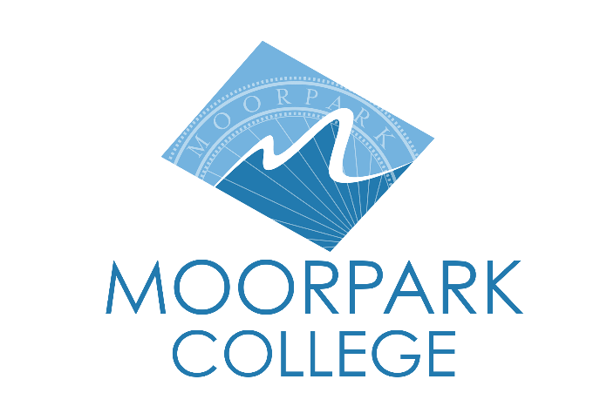

FOR IMMEDIATE RELEASE

Dr. Julius Sokenu Joins Excelencia in Education’s Presidents for Latino Student Success Network
Moorpark College Committed to Serving Latino Students and Being an Inclusive Learning Environment for All

Moorpark, Calif. (April 17, 2025) – Dr. Julius Sokenu, president of Moorpark College, announced his affiliation with the national Presidents for Latino Student Success (P4LSS) network, an initiative of Excelencia in Education—the nation’s premier authority on efforts accelerating Latino student success in higher education. The network comprises presidents and chancellors who have committed to making their campuses learning environments where Latino, and all, students thrive.
Excelencia formed P4LSS in 2014 to support institutional leaders who are transforming higher education to make our country stronger with the contributions, skills, and talents of Latino college graduates. Programs and initiatives that work for Latinos can serve other students as well, and thus the nation at large.
Through the P4LSS network, Dr. Sokenu will collaborate with Excelencia and other postsecondary leaders to leverage collective expertise and resources, foster partnerships, and amplify current efforts to accelerate Latino student success in higher education at the national level.
“Institutional leadership focused on intentionally serving Latino, and all, students is the hallmark of the presidents and chancellors in this network," said Sarita Brown, co-founder and president of Excelencia in Education. “We are proud to catalyze and support them as they advance student success and grow talent for our country’s bright future."
Dr. Sokenu joins more than 150 leaders that belong to the P4LSS network and lead the nation in enrolling and graduating Latino students. Although the network represents only 5% of the thousands of colleges and universities across the country, the network enrolls 32%, and graduates 34%, of all Latino students in higher education.
“I am honored to join the Presidents for Latino Student Success Network,” said Dr. Sokenu. “Moorpark College has a record of creating inclusive learning communities that motivate and celebrate Latino/a student success. We couple high expectations with high support. This network provides me and my team access to cohort-based learning opportunities that align institutional efforts and establish evidence-based practices to authentically and intentionally serve students.”
Dr. Sokenu’s affiliation with the P4LSS network reflects Moorpark College’s continued commitment to intentionally serving Latino students and removing barriers to completion. To learn more about the Presidents for Latino Student Success network and other institutional leaders across the country affiliated with Excelencia, visit EdExcelencia.org/leadership/presidents-latino-student-success
###
About Excelencia in Education
In 2024, Excelencia in Education marked 20 years of service accelerating Latino student success in higher education by promoting Latino student achievement, conducting analysis to inform educational policies, and advancing institutional practices while collaborating with those committed and ready to meet the mission. Excelencia has established a network of results-oriented educators and policymakers to address the U.S. economy’s needs for a highly educated workforce and engaged civic leaders. For more information, visit: EdExcelencia.org
About Moorpark College
Moorpark College is one of three colleges in the Ventura County Community College District and annually serves more than 14,000 students. Founded in 1967, Moorpark College is fully accredited and has the highest six-year completion rate within the California Community College System. An Aspen Institute Top 10 Finalist for 2023, Moorpark College has also been named a 2020 Champion of Higher Education by The Campaign for College Opportunity for the Associate Degree for Transfer Pathway. It is also a designated Hispanic-Serving Institution. The college’s signature career/technical programs include nursing, radiologic technology, biotechnology and journalism. The college’s America’s Teaching Zoo is the only associate degree exotic animal training program in the country. To learn more, visit MoorparkCollege.edu or follow @MoorparkCollege on social media.

Media Contact:
communications@vcccd.edu
805-652-5502

