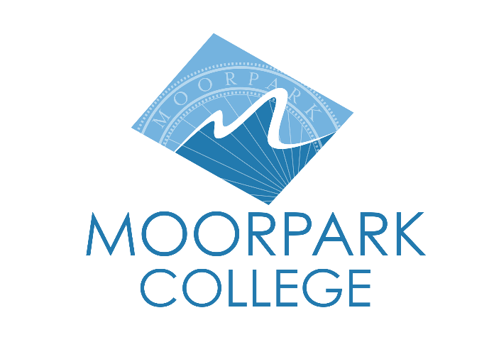 | Moorpark College  7075 Campus Road  Moorpark, CA 93021  805-378-1400  moorparkcollege.edu
Moorpark College Advances to Top 10 in National Competition for $1 Million Prize
Aspen Institute Names Top 10 Community Colleges from Across the Country
Moorpark, Calif. (June 12, 2024) – Moorpark College has been named a top 10 finalist for the 2025 Aspen Prize for Community College Excellence. Presented by The Aspen Institute College Excellence Program, the $1 million award is the nation's signature recognition of strong performance among community colleges. The institutions selected for this honor stand out among more than 1,000 community colleges nationwide as having high and improving levels of student success, as well as equitable outcomes for Black and Hispanic students and those from lower-income backgrounds.
Moorpark College was a finalist in the 2023-24 award cycle, ultimately placing third for the Aspen Prize for Community College Excellence.
Julius Sokenu, President of Moorpark College, described being recognized as a finalist for the Aspen Prize for Community College Excellence two years in a row.
“This recognition is an incredible honor. It’s also a testament to the work Moorpark College does each year to improve our students’ experiences and support their success. In the last year, Moorpark College has increased academic counseling support for students, enhanced programs and resources to meet the needs of disproportionately impacted student populations, and expanded our learning support services to improve student outcomes in transfer level courses. Receiving recognition for our ongoing work to ensure our students’ success is a great honor for our faculty, classified professionals, and administrators.”
The Aspen Prize selection process began in the summer of 2023 when Aspen analyzed data on 1,000 community colleges in key areas such as retention, completion, and transfer. In October, Aspen invited 150 community colleges to apply based on data showing high, improving, and equitable levels of student success. The 118 submitted applications went to a selection committee of 18 higher education experts who assessed each application based on extensive data and narrative answers to questions. Following interviews with leadership teams from applicants receiving top scores, 20 semifinalists were selected and announced in May. The committee continued its review and narrowed the field to the 10 finalists. In this year’s award cycle, Moorpark College is the only California Community College that advanced as a finalist.
“This latest recognition is a reflection of the extraordinary leadership, collaboration and innovative spirit within our college community,” said Bernardo Perez, chair of the Ventura County Community College District Board of Trustees. “It signifies our ongoing pursuit of excellence in providing transformational educational experiences for our students. The Board of Trustees is incredibly proud of this repeat accomplishment and are dedicated to advancing our mission of student success and equity.”
Awarded every two years, the Aspen Prize honors colleges with outstanding performance in six critical areas: teaching and learning, certificate and degree completion, transfer and bachelor’s attainment, workforce success, broad access to the college and its offerings, and equitable outcomes for students of color and students from low-income backgrounds. The winner will be announced in the spring of 2025 in an award ceremony hosted in Washington, D.C.
Rick MacLennan, Chancellor of the Ventura County Community College District, shared his excitement, stating, "Being named a finalist for the Aspen Prize for a second time is a profound honor and a testament to the hard work and dedication of our faculty, staff and students. It reaffirms our unwavering commitment to excellence and equity in education. We are deeply proud for Moorpark College to be recognized among the nation's best community colleges!"
Moorpark College eagerly awaits the next steps in the award selection process, which includes a multi-day in-person site visit to each of the 10 colleges recognized as finalists. The Aspen team will be visiting Moorpark in the Fall of 2024 to collect additional information, conduct interviews, and examine transfer, employment, and earnings data for Moorpark College graduates.
For more information about Moorpark College and our award-winning programs for students, please visit the Moorpark College website.

About Moorpark College
Grounded in equity, social justice, and a student’s first philosophy, Moorpark College values diverse communities. We empower learners from local, national, and global backgrounds to complete their degree, certificate, transfer, and career education goals. Through innovation and customized student support, our programs are designed to achieve equitable outcomes.
Moorpark College is one of three colleges in the Ventura County Community College District and annually serves more than 14,000 students. Founded in 1967, Moorpark College is fully accredited and has the highest six-year completion rate within the California Community College System. An Aspen Institute Top 10 Finalist for 2023, Moorpark College has also been named a 2020 Champion of Higher Education by The Campaign for College Opportunity for the Associate Degree for Transfer Pathway. It is also a designated Hispanic-Serving Institution. The college’s signature career/technical programs include nursing, radiologic technology, biotechnology and journalism. The college’s America’s Teaching Zoo is the only associate degree exotic animal training program in the country. To learn more, visit MoorparkCollege.edu or follow @MoorparkCollege on social media.

About the Aspen Institute
The Aspen Institute is a global nonprofit organization whose purpose is to ignite human potential to build understanding and create new possibilities for a better world. Founded in 1949, the Institute drives change through dialogue, leadership, and action to help solve society’s greatest challenges. It is headquartered in Washington, D.C. and has a campus in Aspen, Colorado, as well as an international network of partners. For more information, visit www.aspeninstitute.org.
Media Contact:
Jamie Whittington Studer
Public Information Officer
jamie_whittingtonst1@vcccd.edu
805-378-1400

