|  |
| --- |
|  |

**FOR IMMEDIATE RELEASE**

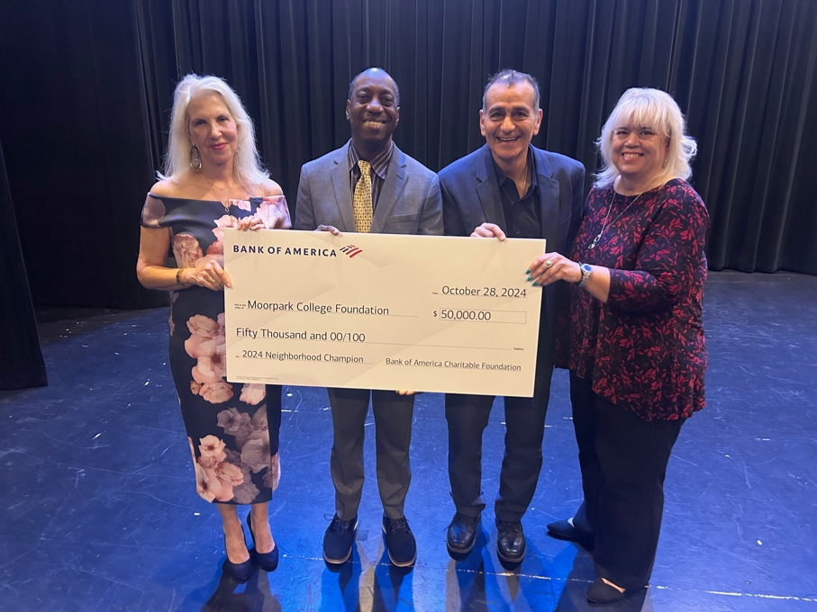

**Celebrating 5 Years of Neighborhood Champion Program in Ventura/Santa Barbara, BofA Names Moorpark College as its 2024 Neighborhood Champion Recipient**

**Moorpark, Calif.** (Nov. 13, 2024) — Commemorating its fifth year, Bank of America’s [Neighborhood Champions®](https://urldefense.com/v3/__http:/www.bankofamerica.com/neighborhoodbuilders__;!!JboVxjCXSME!IkFa3niymOxTV0L-NnnB2hDaOpHnKcrEcT1HJgBgzj6SvNZLfOwLxwuRXO2kxhzjLZzUL0q2LBeWgMRQw9LEDm6rAdXM0i8$) program provides multiyear flexible grant funding annually to high-impact nonprofits in nearly 40 communities nationwide. In the Ventura/Santa Barbara market, Bank of America has named[Moorpark College Foundation](https://urldefense.com/v3/__https:/www.moorparkcollege.edu/__;!!JboVxjCXSME!IkFa3niymOxTV0L-NnnB2hDaOpHnKcrEcT1HJgBgzj6SvNZLfOwLxwuRXO2kxhzjLZzUL0q2LBeWgMRQw9LEDm6rMVzf4g4$) as its local 2024 Neighborhood Champion for its work to remove barriers to employment and re-skill the local workforce.

As a Neighborhood Champion, Moorpark College Foundation receives a $50,000 grant over two years, leadership training resources for the organization’s executive director, access to technical coaching and a national network of nonprofit peers.

“This year we celebrate five years of strengthening Ventura and Santa Barbara-area nonprofits that deliver solutions to local challenges through the Neighborhood Champions program," said Midge Campbell-Thomas, president, Bank of America Ventura/Santa Barbara. “Providing high-impact nonprofits like Moorpark College with flexible funding and leadership training helps them address critical needs and create meaningful lasting change. Countless individuals, families and neighborhoods have felt the profound impact that these Neighborhood Champion nonprofits have had locally over the past five years.”

The Central Coast region has experienced a surging demand for tech-related jobs over the last two decades, with approximately 13,000 tech roles according to [a recent study by REACH](https://urldefense.com/v3/__https:/reachcentralcoast.org/wp-content/uploads/REACH-Technology-Report.pdf__;!!I2XIyG2ANlwasLbx!XiTXd2Dm4S26yPGF4ysEc9NBWxKHlk4Dq4AHgxEnB5RsYcUTi0_gi9npn0g6Dhq763BRJLq2m50mf_1iP8C7OhsLg4NWpAob8tveTA$). To keep up with demand, Moorpark College will use its Neighborhood Champion grant towards its Computer Network Systems Engineering and Cybersecurity (CNSE) certificate program that provides upskilling and reskilling to students and builds pathways to high-skill, high-wage and in-demand careers for students to help fill job vacancies in the local tech industry. Specifically, the funds will support a new pilot program — Access, Achieve, Advance (AAA) — which removes financial barriers associated with obtaining professional certifications by subsidizing the cost of preparing for and passing up to three critical certification exams that are essential to advancing in the tech industry.

“Moorpark College and the Moorpark College Foundation are honored by Bank of America’s recognition of the role programs like our CNSE play in preparing students for high skill, high wage in demand careers. This grant will change lives, strengthening the economy of Ventura County by producing the technicians needed to support the cybersecurity sector,” said Dr. Julius Sokenu, Moorpark College President.

“Our Cybersecurity students will greatly benefit from this Bank of America grant. This grant removes financial barriers and empowers students to pursue professional certification essential to demonstrating their skills and increasing their confidence. With these professional credentials, students are better prepared to enter the workforce, ultimately enhancing their career prospects and contributing to the economic vitality of our community.  Bank of America’s support is invaluable to our hard working and dedicated students as they prepare for impactful careers in cybersecurity.  I am overjoyed with the increased opportunities this grant will provide our students,” shared Professor Ed Garcia, Moorpark College CNSE.

Neighborhood Champions is part of the bank’s longstanding efforts to build thriving communities by addressing issues fundamental to economic opportunity. The invitation-only program is highly competitive, with awardees selected by a committee comprised of community leaders and past awardees. Since 2019, Bank of America has invested over $9 million in more than 200 nonprofits within more than 40 communities through the Neighborhood Champions program.

Past Ventura/Santa Barbara Neighborhood Champions include Big Brothers Big Sisters of Ventura County, Foodbank of Santa Barbara, Habitat for Humanity of Ventura County, Many Mansions and Women’s Economic Ventures.

**About Bank of America**

*Bank of America is one of the world’s leading financial institutions, serving individual consumers, small and middle-market businesses and large corporations with a full range of banking, investing, asset management and other financial and risk management products and services. The company provides unmatched convenience in the United States, serving approximately 69 million consumer and small business clients with approximately 3,800 retail financial centers, approximately 15,000 ATMs (automated teller machines) and award-winning digital banking with approximately 58 million verified digital users. Bank of America is a global leader in wealth management, corporate and investment banking and trading across a broad range of asset classes, serving corporations, governments, institutions and individuals around the world. Bank of America offers industry-leading support to approximately 4 million small business households through a suite of innovative, easy-to-use online products and services. The company serves clients through operations across the United States, its territories and more than 35 countries. Bank of America Corporation stock is listed on the New York Stock Exchange (NYSE: BAC).*

**About Moorpark College**

*Moorpark College’s student-first philosophy embraces equity, social justice, anti-racism, and intersectionality. We empower learners from local, national, and global backgrounds to achieve their certificate, associate and baccalaureate degree, and transfer and career education goals. Through the integration of innovative instruction and holistic student support, our programs are designed to foster equitable student outcomes. To learn more, visit*[*MoorparkCollege.edu*](http://MoorparkCollege.edu)*or follow @MoorparkCollege on social media.*

**About Moorpark College Foundation**

*We serve Moorpark College and all its students by securing resources to empower our students to achieve academic, economic, and personal goals. We change lives for the better. Learn more about*[*Moorpark College Foundation*](https://www.moorparkcollege.edu/community/foundation)*.*

**Media Contacts:**

Colleen Haggerty, Bank of America  
Colleen.Haggerty@bofa.com   
213-621-7414

Deborah Klein  
Chief Development Officer  
Moorpark College Foundation  
[dklein@vcccd.edu](mailto:dklein@vcccd.edu)  
805-553-4760